EXPERIMENT -1

**Establish an AWS account. Use the AWS Management Console to launch an EC2 instance and connect to it.**

**Step1 :** Login into AWS

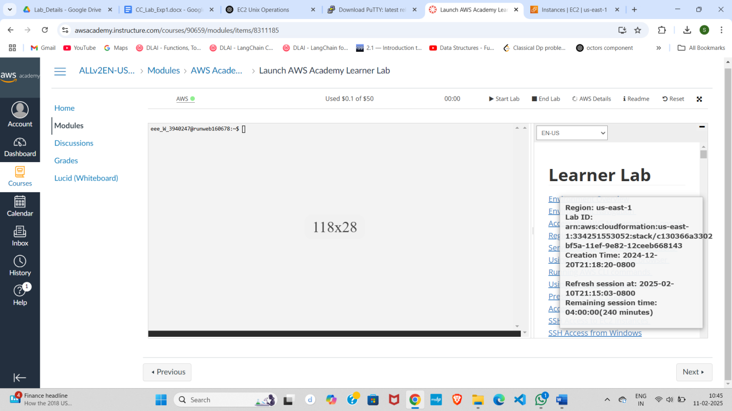

**Step2:** Activate AWS (Green Color) → Click **Start Lab → click AWS search EC2 in** search Bar

1. In search bar type EC2 {Elastic Compute cloud}

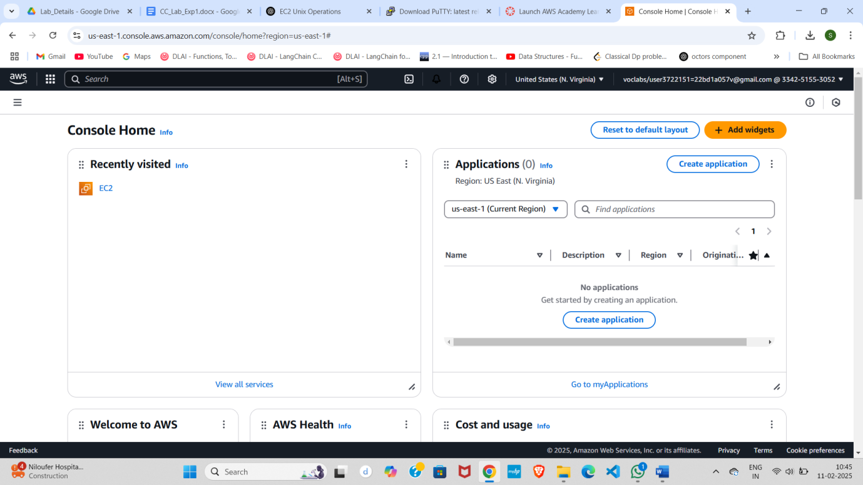

1. You will get EC2 Dashboard contains resources
   1. Instances (choose)
   2. Elastics IPs
   3. Key Pairs
   4. Snapshot
2. First Launch Instance

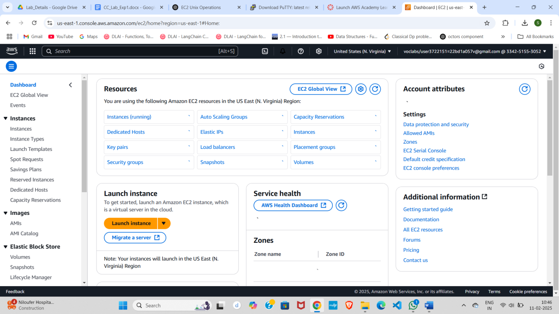

1. EC2 allows you to create virtual machines, or instances, that run on the AWS Cloud
   1. Name and tags : Rollno_EC2
   2. Application and OS Images (Amazon Machine Image) : you can choose Ubuntu /Windows
   3. Amazon Machine Image (AMI) : choose **Free tier eligible** like Amazon Linux 2023 AMI
      1. Description: explains about machine advantage
      2. Architecture: 64 Bit

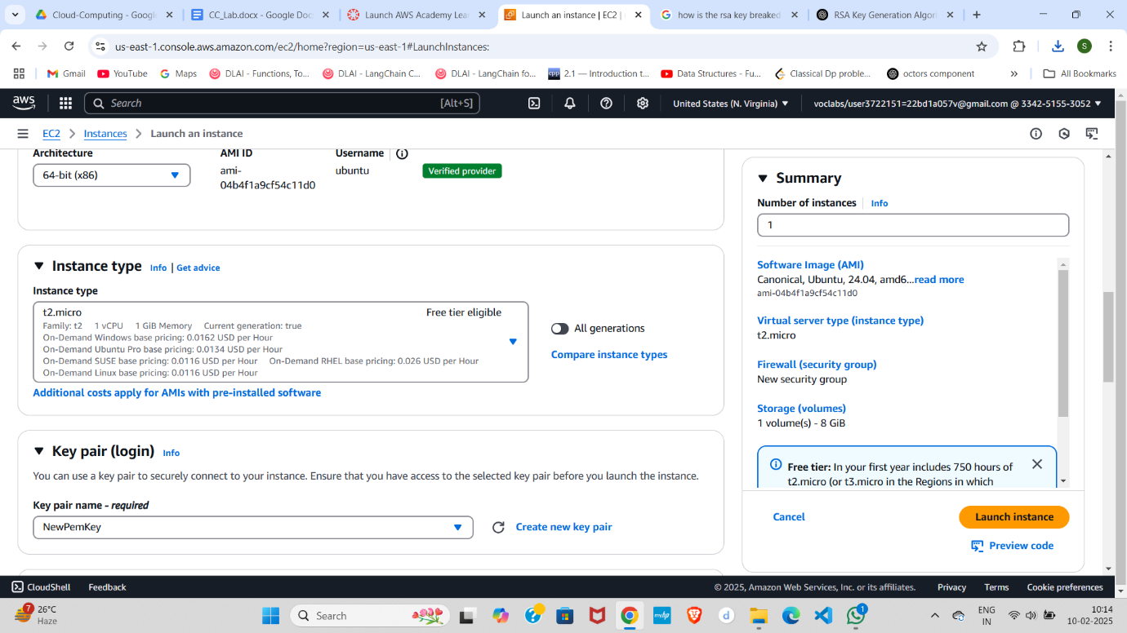

1. Instance type: t2.micro (**Free tier eligible**)
2. Key pair (login) : Create & Download {Everyone have Unique} & Download
   1. RSA (choose)
   2. ED25519

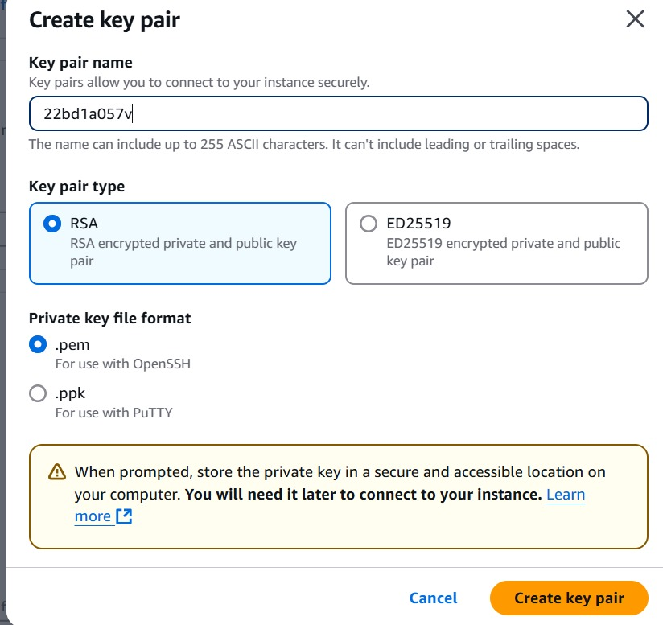

PEM: (Choose)

PPK:

1. **Network settings**  : click checkbox **Allow SSH traffic from** & Choose **Anywhere to access** system

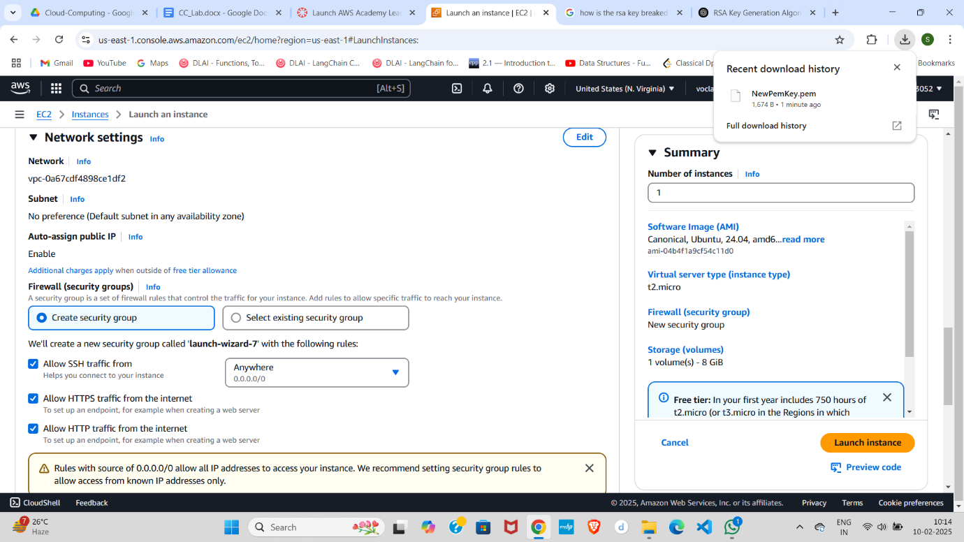

1. Configure storage: 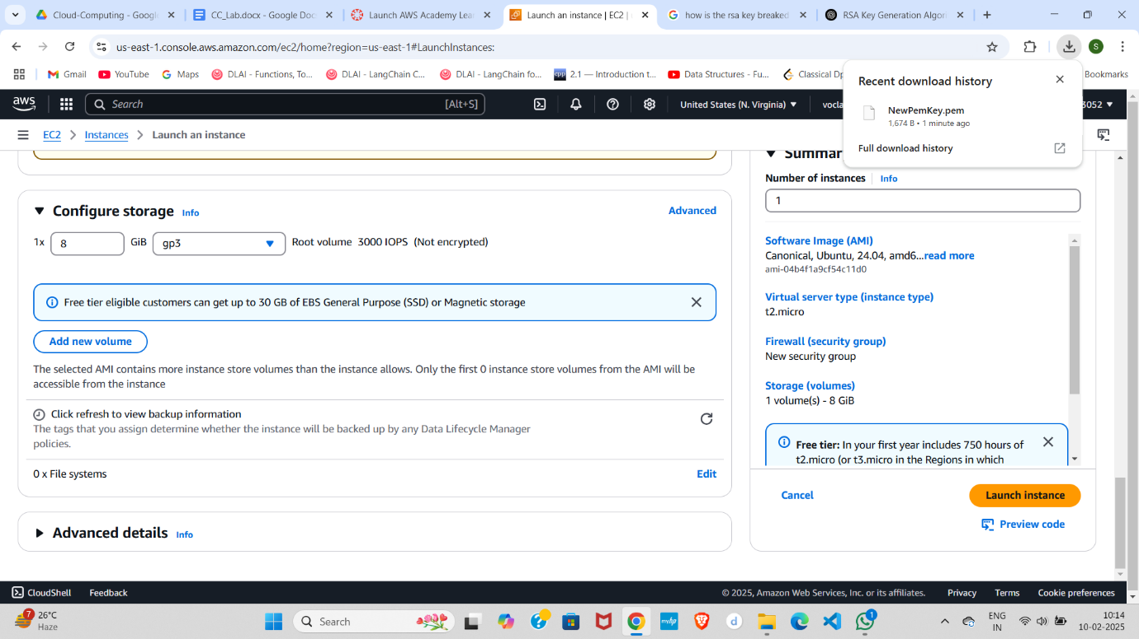
2. In Summary choose 2 Instances

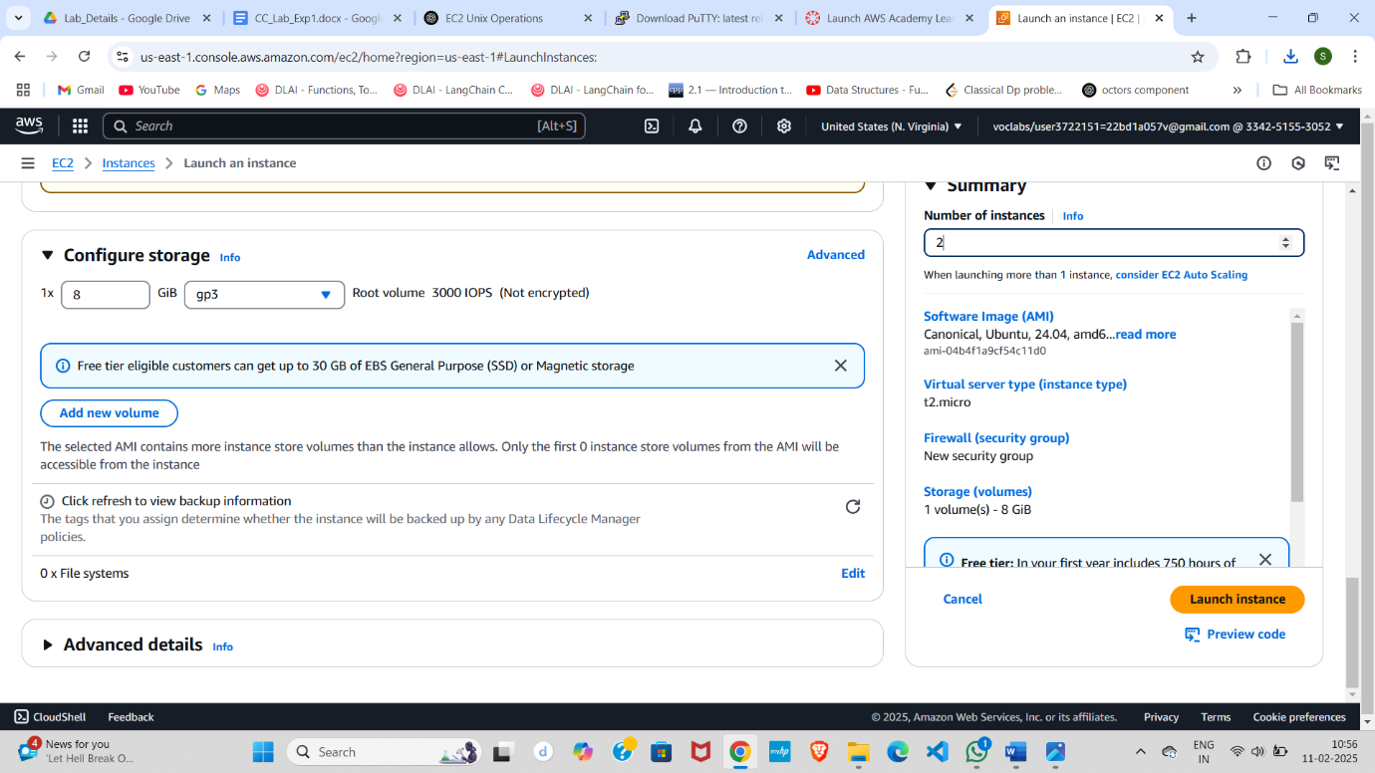

1. Click Launch Instance..
2. GO Back & check Instance is create by 2/2 steps execution 1. For Software check & 2nd for Hardware check
3. Select the Instance Created & Click on **Connect**
4. After connecting UI Look Like Below

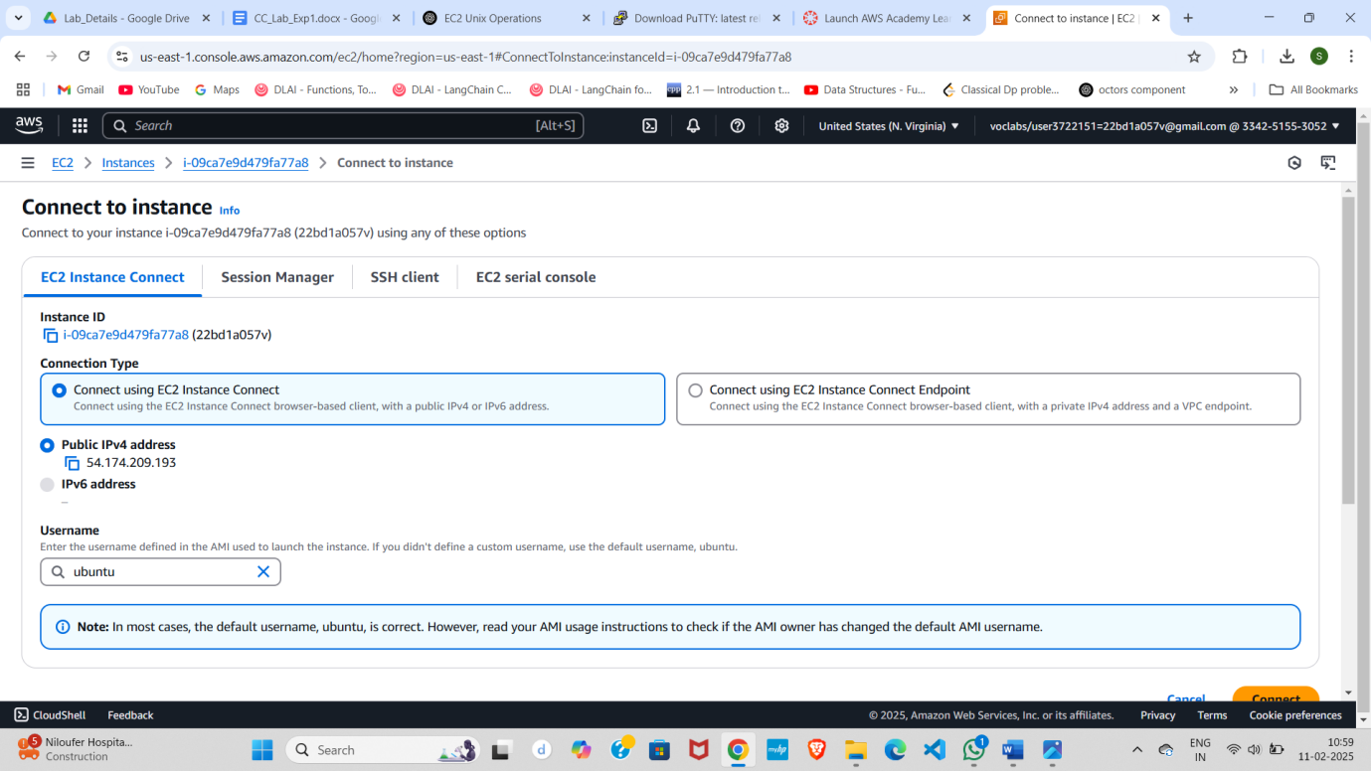

1. First connect with **EC2 Instance Connect** **Method-1**
   1. click on connect
   2. UI Looks Like Below

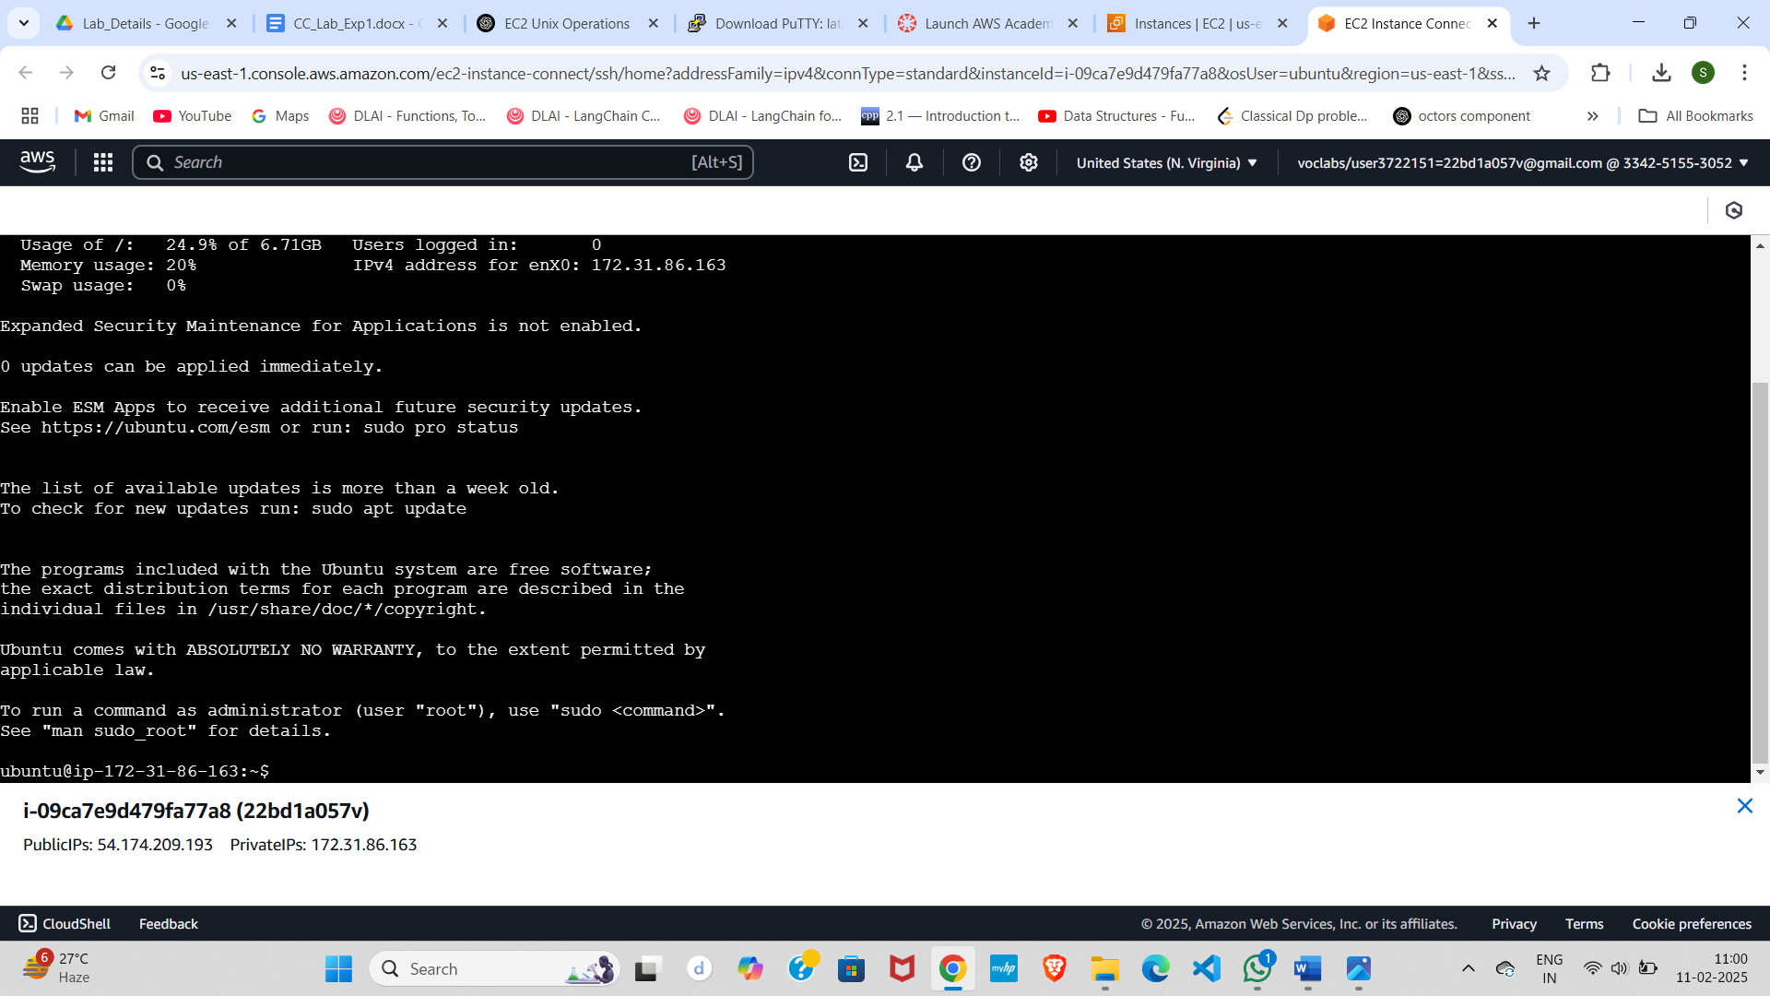

* 1. perform unix commands like create directory with your Roll no, chmod, ls, vi, install java package & run the java code

**Method 2: Connect with SSH**

**CONNECT Putty with EC2 Machine using PEM key pair..**

1. Open putty key generation & load your Private PEM file & Save the Private Key
   1. convert PEM File into PPK (Putty private key)
   2. 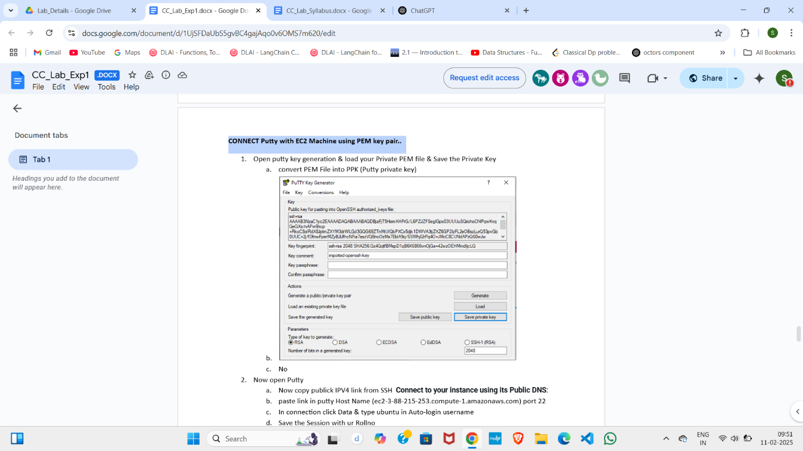
   3. No
2. Now open Putty
   1. Now copy publick IPV4 link from SSH **Connect to your instance using its Public DNS**:
   2. paste link in putty Host Name (ec2-3-88-215-253.compute-1.amazonaws.com) port 22
   3. In connection click Data & type ubuntu in Auto-login username
   4. Save the Session with ur Rollno

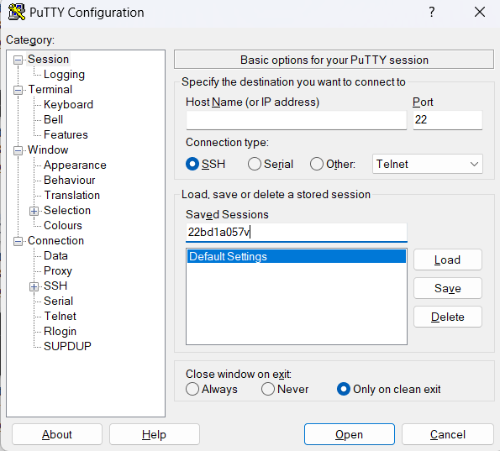

* 1. Load PPK File connection → SSH → Auth → credentials → insert PPK File → click on open

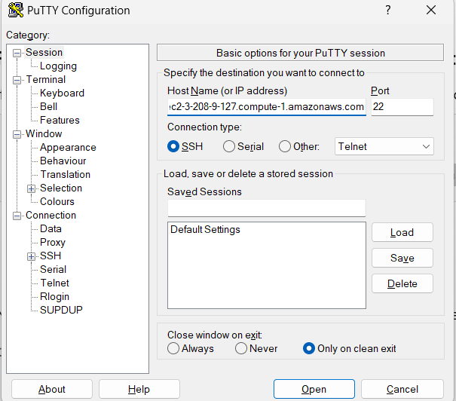

* 1. Accept the pop-up
  2. 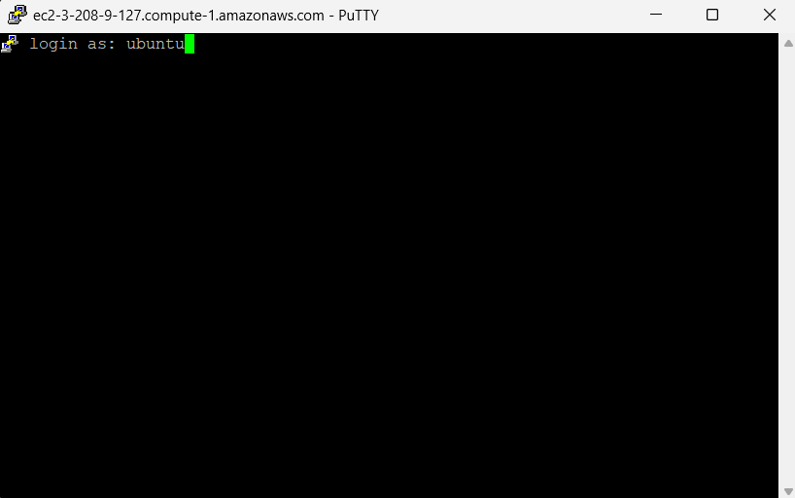
  3. Same console in server terminal as to visible

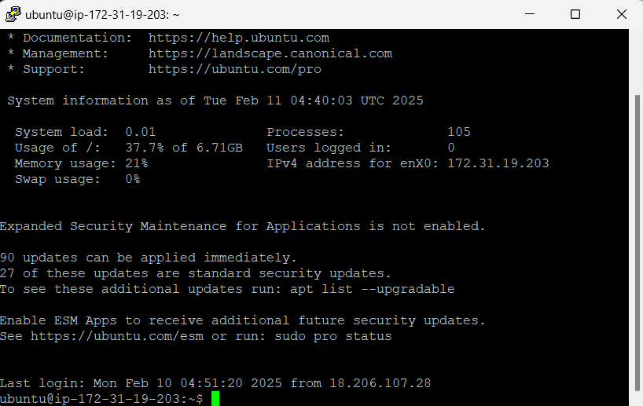

**Update & Upgrade Ubuntu**

Run the following commands to update and upgrade all packages:

sudo apt update && sudo apt upgrade -y

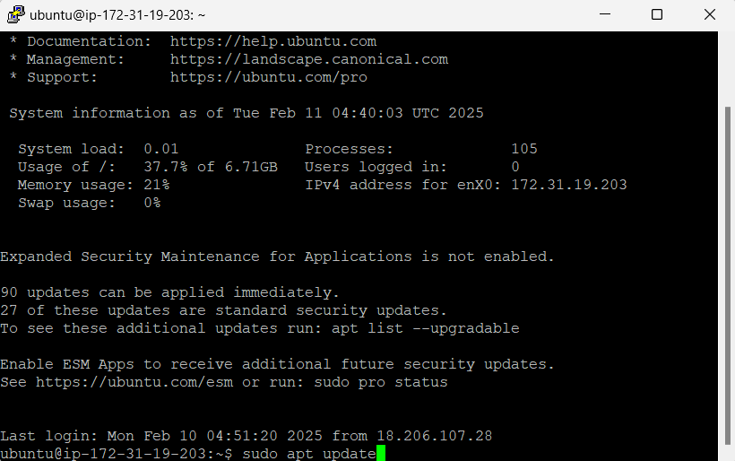

### **Install Java (OpenJDK)**

**Java 21 (Latest LTS)**  
sudo apt install -y openjdk-21-jdk

Check the installed version

java -version

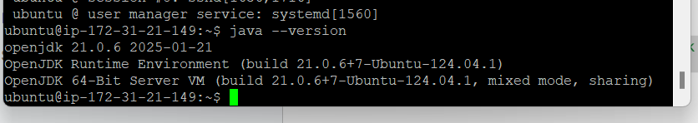

Create a folder with your roll no and set the permissions

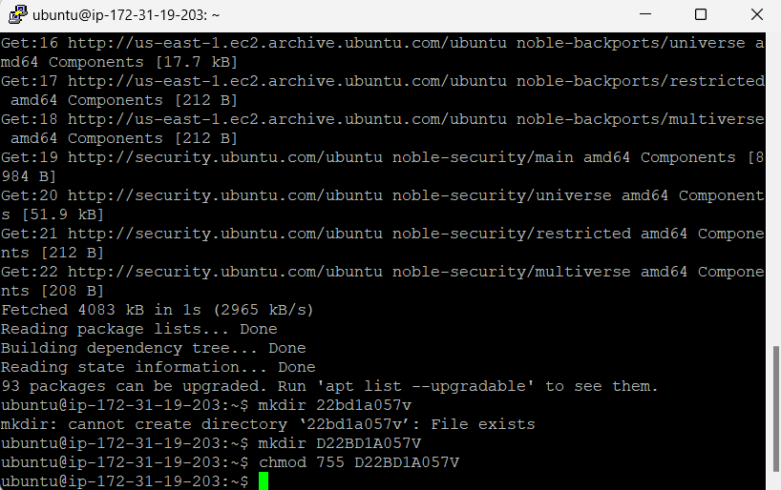

### **Open Vim to Create a Java File**

Run the following command to create and edit a Java file

vi D22BD1A057V.java

**Write Java Code in Vim**

Press **i** to enter **INSERT mode**, then paste the following code:

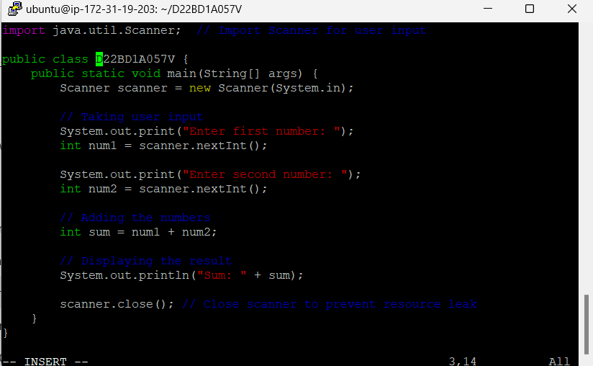

* After pasting the code, press **Esc** to exit **INSERT mode**.
* Type **:wq** and press **Enter** to **save and exit** Vim.

### **Compile the Java Program**

Run the following command to compile the Java program

Javac D22BD1A057V.java

### **Run the Java Program**

Execute the Java file using:

java D22BD1A057V

Output:

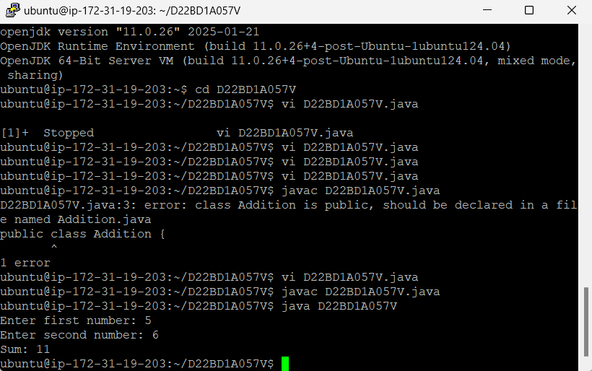

Close the tab and end the session, stop the instance and end the lab